
Company
Logotype

Cone Beam Computed Tomography- Report



Porur Dental X-rays & CBCT

Patient Name : Miss. Hemapriya | Date of Report : 06.03.2024
Age/ Gender : 17 years/ Female | Region of Interest : CBCT Maxilla
Referring doctor: Dr. Madhana Madhubala | Indication : Impacted teeth
Clinical Notes: Nil
PATIENT INFORMATION

CBCT Maxilla provided
CBCT – IMAGE DETAILS

RADIOGRAPHIC INTERPRETATION

- No of teeth (erupted) present in the maxillary alveolar ridge (in total): 16
- The tooth 13 appears to be within the alveolar bone, distally tipped with its crown near the radicular portion of 12 and root of 13 in proximity to the medial wall of right maxillary sinus and root of 14.
- The tooth is positioned palatally and lies involving the palatal cortical bone, with areas of discontinuity of palatal bone.
- In relation to 22 loss of crown structure and remaining radicular portion with hyperdense restorative material with pulp canal is evident.

- Developing crowns of 18, 28.
- Distance between the alveolar ridge and 13: 3.62 mm
- Width of Palatal cortical bone in relation to 13: 0.93 mm

RADIOGRAPHIC IMPRESSION


- Impacted tooth: 13.

IMAGES FOR REFERENCE

PANORAMA VIEW
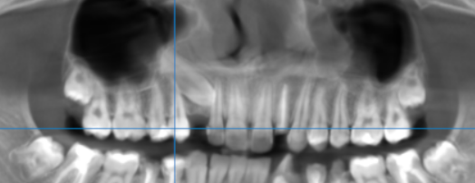

3-DIMENSIONAL VIEW

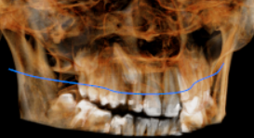
13 REGION | 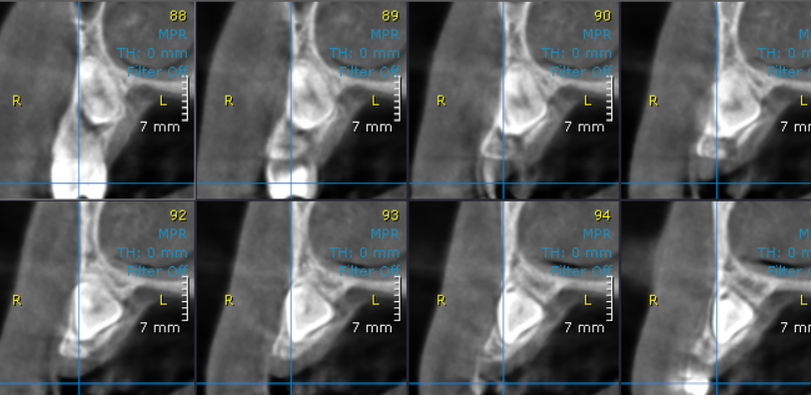
CROSS- SECTIONAL IMAGES

**** End of report ****

